What is Biodiversity?
The variety of life on Earth, its biological diversity is commonly referred to as biodiversity.
The number of species of plants, animals, and microorganisms, the enormous diversity of genes in these species, the different ecosystems on the planet, such as deserts, rainforests and coral reefs are all part of a biologically diverse Earth.
Appropriate conservation and sustainable development strategies attempt to recognize this as being integral to any approach to preserving biodiversity. Almost all cultures have their roots in our biological diversity in some way or form.
Declining biodiversity is therefore a concern for many reasons.

Why is Biodiversity Important?
Biodiversity boosts ecosystem productivity where each species, no matter how small, all have an important role to play.
For example,
- A larger number of plant species means a greater variety of crops
- Greater species diversity ensures natural sustainability for all life forms
- Healthy ecosystems can better withstand and recover from a variety of disasters.
And so, while we dominate this planet, we still need to preserve the diversity in wildlife.

A healthy biodiversity offers many natural services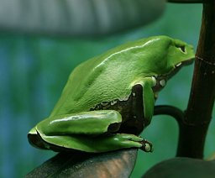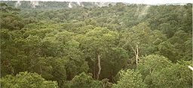

Ecosystems such as the Amazon rainforest are rich in diversity. Deforestation threatens many species such as the giant leaf frog, shown here.
A healthy biodiversity provides a number of natural services for everyone:
- Ecosystem services, such as
  - Protection of water resources
  - Soils formation and protection
  - Nutrient storage and recycling
  - Pollution breakdown and absorption
  - Contribution to climate stability
  - Maintenance of ecosystems
  - Recovery from unpredictable events
- Biological resources, such as
  - Food
  - Medicinal resources and pharmaceutical drugs
  - Wood products
  - Ornamental plants
  - Breeding stocks, population reservoirs
  - Future resources
  - Diversity in genes, species and ecosystems
- Social benefits, such as
  - Research, education and monitoring
  - Recreation and tourism
  - Cultural values
That is quite a lot of services we get for free!
The cost of replacing these (if possible) would be extremely expensive. It therefore makes economic and development sense to move towards sustainability.

Species depend on each other
While there might be survival of the fittest within a given species, each species depends on the services provided by other species to ensure survival. It is a type of cooperation based on mutual survival and is often what a balanced ecosystem refers to.

Soil, bacteria, plants; the Nitrogen Cycle
The relationship between soil, plants, bacteria and other life is also referred to as the nitrogen cycle:
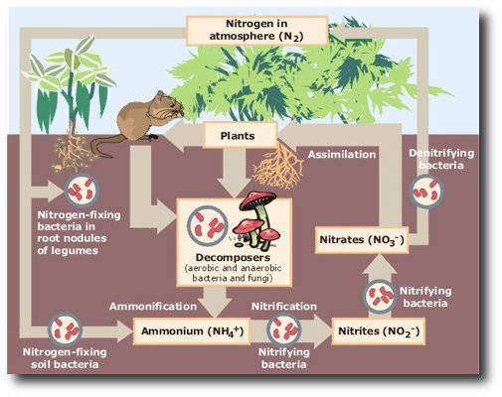(Image source: Wikipedia)
As an example, consider all the species of animals and organisms involved in a simple field used in agriculture. As summarized from Vandana Shiva, Stolen Harvest (South End Press, 2000), pp 61–62:
- Crop byproducts feed cattle
- Cattle waste feeds the soil that nourish the crops
- Crops, as well as yielding grain also yield straw
  - Straw provides organic matter and fodder
  - Crops are therefore food sources for humans and animals
- Soil organisms also benefit from crops
  - Bacteria feed on the cellulose fibers of straw that farmers return to the soil
  - Algae provide organic matter and serve as natural nitrogen fixers
  - Rodents that bore under the fields aerate the soil and improve its water-holding capacity
  - Spiders, centipedes and insects grind organic matter from the surface soil and leave behind enriched droppings.
  - Earthworms contribute to soil fertility
    - They provide aerage, drainage and maintain soil structure.
    - The earthworm is like a natural tractor, fertilizer factory and dam, combined!
- Industrial-farming techniques would deprive these diverse species of food sources and instead assault them with chemicals, destroying the rich biodiversity in the soil and with it the basis for the renewal of the soil fertility.

I ANSWER THE QUESTIONS
- What is biodiversity and why is it important?
- Why is deforestation dangerous?
- Explain some of the benefits that humans can have from healthy biodiversity. Try to focus just on some benefits in more detail.
- What does the phrase survival of the fittest mean?
- What is the nitrogen cycle?
- Explain how crops are food sources both for humans and animals.
- Why are earthworms so important for soil fertility?
Useful vocabulary:
Bore-kopati
Crop-usev, prinos, rod
Cattle-stoka
Fodder-stočna hrana
Fiber-vlakno
Fertility-plodnost
Grain-zrno, seme
Rodent-glodar
Straw-stabljika, slamka
Soil-tlo, zemljište

